
City of West Covina

Notice of Intent to Adopt a Mitigated Negative Declaration and Planning Commission Public Hearing Notice

Pursuant to the State of California Public Resources Code Section 21092, this is to advise you that the City of West Covina has prepared an Initial Study of environmental impacts for the following project:
Case No.: Conditional Use Permit No. 23-04, Precise Plan No. 23-05, Variance No. 24-02 and Tree Removal Permit No. 25-01
Project Title: West Covina Medical Center Behavioral Heath Building Addition Project
Applicant: Nick Hermann, Building Resources
Project Location: 725 South Orange Avenue (APN 8474-001-022)
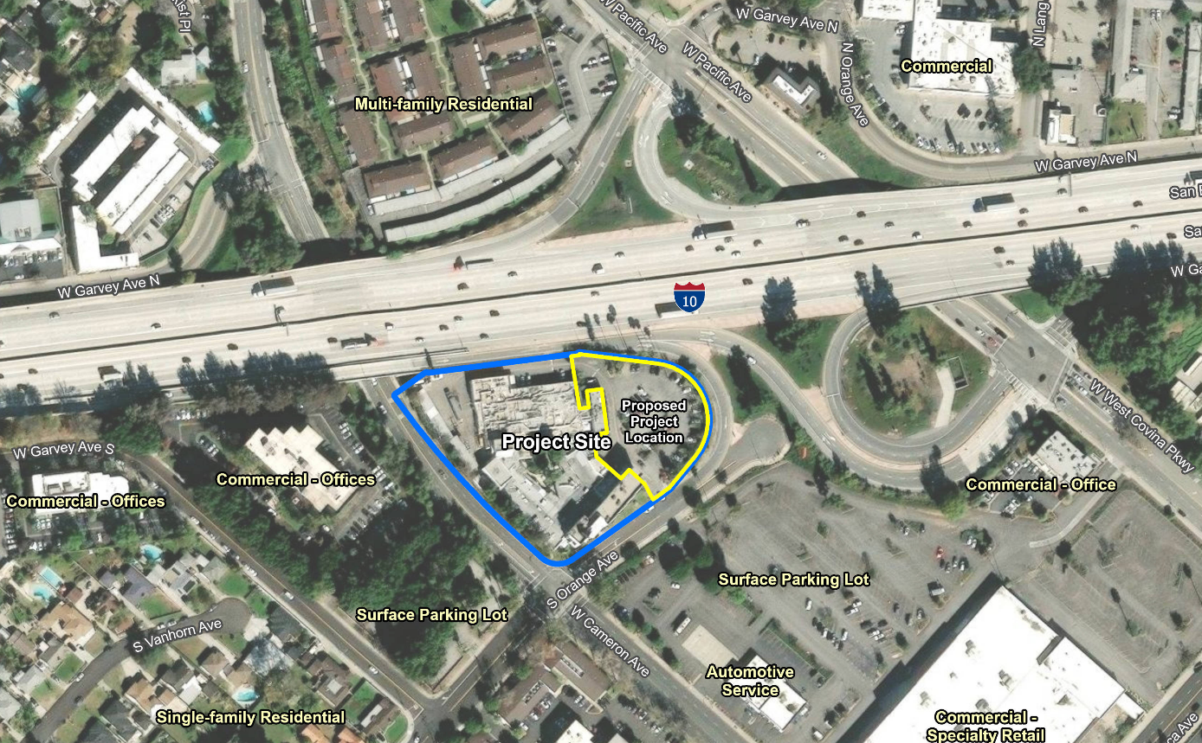
Project Description: The proposed project would construct a four-story 42,000-square foot behavioral health facility on the east side of the 2.83-acre West Covina Medical Center property. The proposed building would be up to 70 feet in height and would have 71 licensed beds, patient and ambulance drop-off areas, a loading and receiving area, and a kitchen service area. The kitchen services area would serve the existing 46 patient beds in the existing medical facility and the 71 patient beds for the proposed building. Outdoor activity space would be located at the eastern end of the second floor and at the western end of the fourth floor of the proposed building. The existing 38 trees to the east of the property, of which 25 trees are classified as significant trees per Section 26-258 of the West Covina Municipal Code, would be removed,
The building entrance and patient drop-off area would be located to the southeast of the proposed building. The ambulance drop-off area would be on the north side of the proposed building, near the I-10 freeway. All patients are expected to be transported to the proposed building for treatment via ambulance or non-medical emergency transport van from another facility (such as a skilled nursing or residential care facilities). No sirens would be used.
The existing 55 parking spaces at the eastern portion of the project site would be removed and four parking spaces would remain. The existing ten parking spaces on the north side of the existing building would remain, while the carport and parking spaces to the west of the existing building would be removed with only two parking spaces remaining. The existing 132 off-site surface parking spaces on the west side of Orange Avenue (across the street from the project site) would remain unchanged.
Environmental Determination: Based on the findings of the Initial Study, the City has determined that this project would not result in significant environmental impacts. Mitigation measures for biological resources, cultural resources, geology and soils, noise, transportation, and tribal cultural resources will be required to reduce impacts to a less than significant level. Accordingly, the City intends to adopt a Mitigated Negative Declaration, pursuant to Section 21080(c) of the Public Resources Code. The project site is listed on the Geotracker database as a leaking underground storage tank cleanup site, but the cleanup status of the project site is listed as completed and closed as of December 13, 2007. The project site is not included on any other list of hazardous materials facilities, hazardous waste properties, or hazardous waste disposal sites enumerated under Section 65962.5 of the California Government Code (Cortese List).
Public Review Dates: The public comment period during which the City of West Covina will receive written comments on the Mitigated Negative Declaration is:
January 15, 2025 – February 3, 2025
The City of West Covina must receive all written comments relating to the Mitigated Negative Declaration no later than 5:00 pm on February 3, 2025. Please direct your written comments to:
Jo-Anne Burns, Deputy Development Director
City of West Covina, Planning Division
1444 West Garvey Avenue S, Room 208
West Covina, California 91790

Or via e-mail to: jburns@westcovina.org

Document Availability: The Mitigated Negative Declaration, as well as all referenced documents are available for public review online. Please visit: https://www.westcovina.org/departments/community-development/planning-division/projects-and-environmental-documents.
Public Hearing: The West Covina Planning Commission is scheduled to consider the Mitigated Negative Declaration and the proposed project at its regular meeting on February 11, 2025, at 7:00 P.M. at 1444 W. Garvey Avenue South, West Covina, CA, in the City Hall Council Chambers located on the 1st Floor. The meeting is open to the public. The public may also watch the Planning Commission Meeting live on the City’s website at https://www.westcovina.org/departments/city-clerk/agendas-and-meetings/current-meetings-and-agendas under the “Watch Live” tab or through the West Covina City YouTube channel at www.westcovina.org/LIVE. To confirm the date and time of the meeting and for additional information concerning the proposed project, please check the City’s website: http://www.westcovina.org/home.
If you wish to challenge the action(s) taken on the request(s), you may be limited to raising only those issues, which you (or someone else) raised orally at this public hearing or in written correspondence received by the City at or before the hearing.
If you have any questions or would like any additional information, please contact Jo-Anne Burns of the Planning Division at (626) 939-8422, or at jburns@westcovina.org.

